Power BI Assignment 1 – Data Transformation & Data Modeling
Import Data:
Import “List of Orders.csv” into Power BI.
Power BI desktopblank documenthomeget datatext/csvselect the list of orders csv file click load
Open “List of Orders” in Power Query Editor by clicking on ‘Transform’.
After loading list of orders csv file hometransform datapower query editor will openapply necessary changesclick close and load
Import “Order Details.csv” and “Sales target.csv” into Power Query Editor.
Homeget datatext/csvorder details & sales target csv filestransformpower query editor will openapply necessary changesclick close & load

Data Transformation:
Restrict the "List of Orders" table to only the first 500 rows.
Home option in power BItransform datapower query editor will openhome option in power querykeep rowskeep top rowsenter 500 rows ok
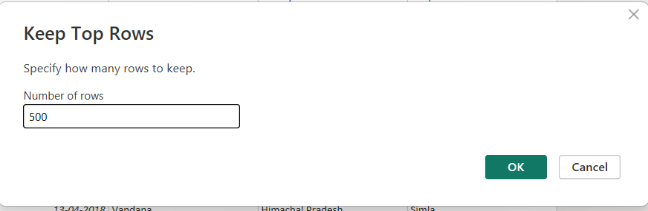

Ensure the “Order Date” column in the “List of Orders” table is set to data type 'Date'.
In power query
Select the order date columnTransformdata typeselect date

Change the data type of “Amount” and “Target” columns to ‘Fixed Decimal Number’.
Select the amount & target columns transformdata typechange to fixed decimal number by replacing the existing column or adding a new column
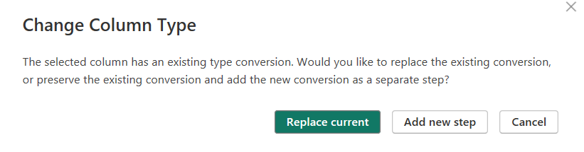
Format the "CustomerName" column into proper case, ensuring consistent capitalization for each word.
Select the customer name column transformformatcapitalize each word
Merge the "State" and "City" columns to create a new column named "Location" in the format ‘City, State’.
Select both state columntransformmove to right
Select both city and state columnstransformmerge columnsuse any separatorname the new columnok
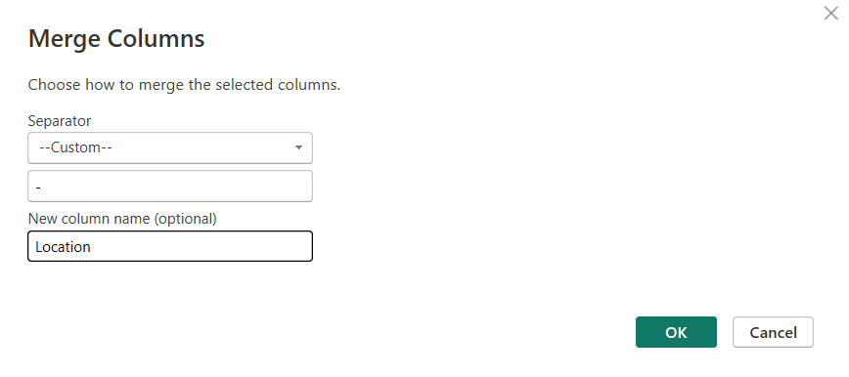

Create a new custom column named "Profit Margin" as the percentage of "Profit" divided by "Amount".
Add columncustom column name the new column to Profit margin insert the formula change the data type to decimal number
Add a new conditional column named "Profit Status" based on the values in the "Profit" column. The conditions are as follows: if the profit is less than 0, the label should be "Loss"; if the profit equals 0, the label should be "Break-Even"; and if the profit is greater than 0, the label should be "Profit".
Add columnconditional columnname the new columnadd the necessary rules okchange the data type to text
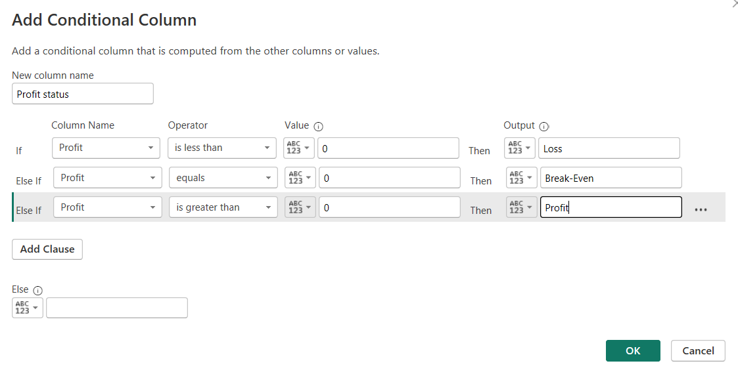

Merging Data (Joins):
Merge the "List of Orders" and "Order Details" tables into a new single table named "Orders Data" based on the "Order ID" relationship.
Homemerge queriesmerge queries as new1st table list of orders & 2nd table order detailsselect order id in both tablesjoin kind -left outerok
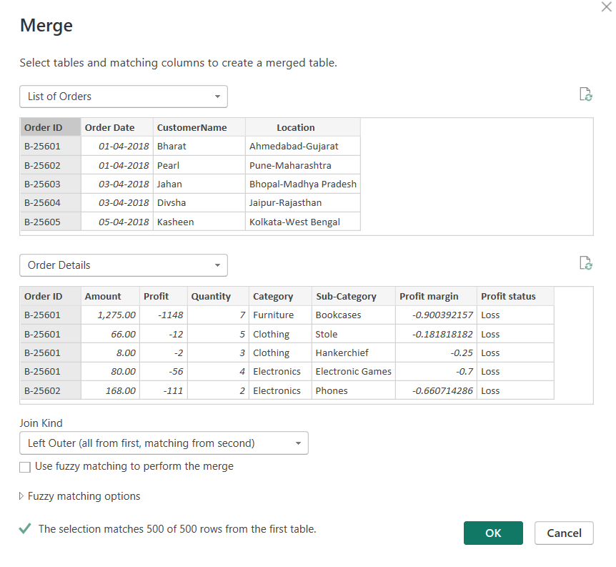
Expand the newly added columnexpand remaining columnsrename the column names
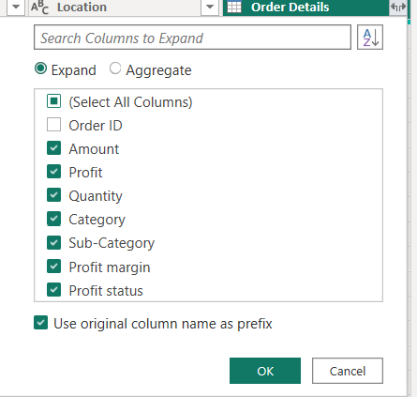

Handling Missing Data & Duplicate Data:
Identify missing values in the data and determine a strategy to address them.
Identify blanks using column filters
Recommended strategies:
- Numeric fields → Replace with 0 or Average
- Text fields → Replace with "Unknown"
- Critical IDs → Remove rows

Check for duplicate rows and define a strategy to handle duplicates.
Duplicate data strategy:
Select the tablehomeremove rowsremove duplicates

Sorting and Filtering Data:
● In the ‘Orders Data’ table, utilize sorting and filtering techniques on columns like Order Date, State or Category to analyze data based on specific criteria:
◆ Sort the orders by Order Date in descending order to analyze recent trends.
Select order dateclick filtersort by descending
◆ Filter the orders to focus only on a specific state (e.g., Tamil Nadu) for regional analysis.
Select location columnclick filterselect tamilnadu shows regional state analysis

Grouping and Aggregating Data:
● Duplicate the “Order Details” table and calculate the count of each Order ID, average profit by Category or total amount by Sub-Category.
Right click order details table duplicate
In duplicate table
Homegroup byselect order-IDrename new columnselect required operationok
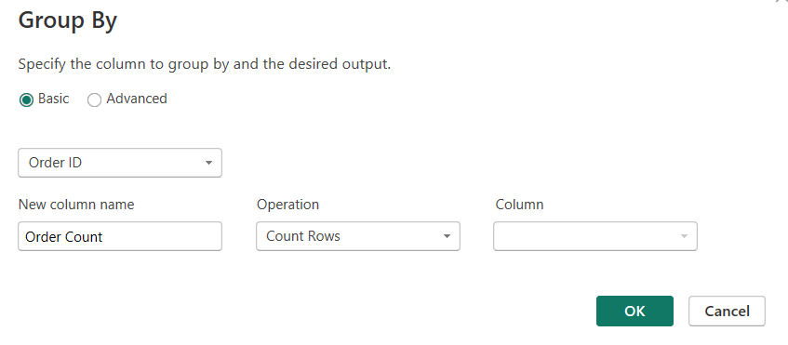
Right click order details table duplicate
In duplicate table
Homegroup byselect categoryrename new columnselect required operation as average Column-profitok
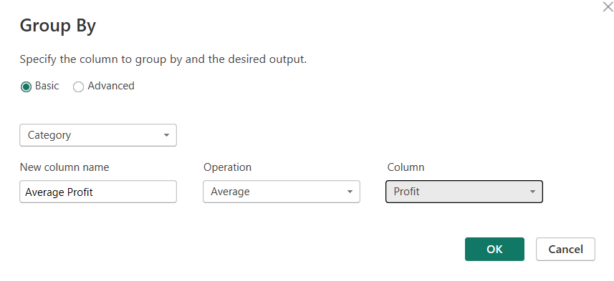
Right click order details table duplicate
In duplicate table
Homegroup byselect sub-categoryrename new columnselect required operation as sum Column-amountok

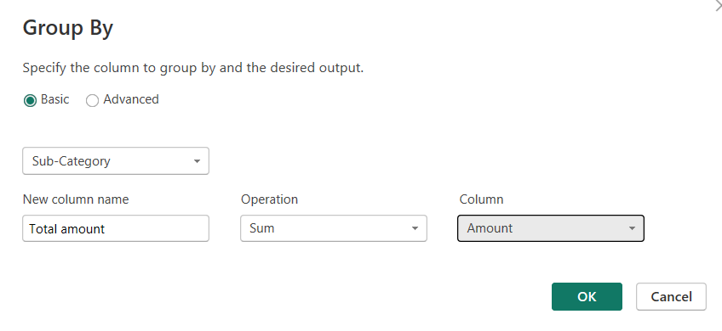
● Duplicate the “Sales Target” table and aggregate the total target amount by Month of Order Date.
Right click sales target tableselect order date columntransformdatename of monthhomegroup bymonthrename new columnselect operation as sumcolumn target ok
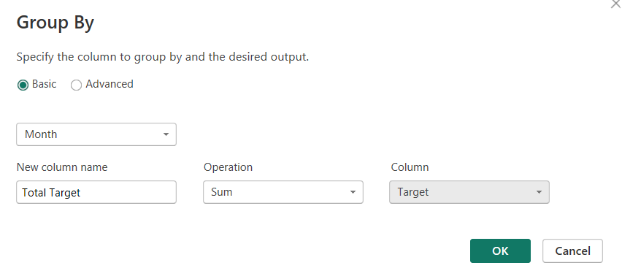

Data Modeling:
Establish a relationship between the “List of Orders” and “Order Details” tables using the ‘Order ID’ column.
Power bi desktopmodel view iconcheck for the tables list of orders and order details Click Order ID in List of OrdersDrag it to Order ID in Order DetailsRelease the mouse Relationship dialog opens automatically-->
Setting | Value
From table - | List of Orders
To table - | Order Details
Column - | Order ID → Order ID
Cardinality - | One to Many (1:*)
Cross filter direction | - Single
Make relationship active | - Checked
- A line appears between the two tables
- Symbols shown:
  - 1 near List of Orders
  - * near Order Details
This confirms the relationship is correct
A relationship was established between the List of Orders and Order Details tables using the Order ID column. Since one order can contain multiple order items, a one-to-many relationship was created, with List of Orders on the one side and Order Details on the many side. This relationship enables accurate analysis of order and product-level data.

Build a relationship between the “Order Details” and “Sales Target” tables based on the ‘Category’ column. Click "Manage relationships" and ensure this relationship is active.
A relationship between Order Details and Sales Target could not be created directly due to duplicate values in the Category column. Therefore, a Category dimension table with unique values was created. One-to-many relationships were then established from the Category dimension to both Order Details and Sales Target using the Manage Relationships option, and both relationships were kept active.
Sure 😊
Here it is in very simple, short steps — perfect to write in your assignment 👇

Relationship between Order Details and Sales Target (Category)
Step 1
Open Power BI Desktop and go to Transform Data.
Step 2
Create a new table for Category:
- Right-click Order Details
- Click Reference
- Keep only the Category column
- Remove duplicate values
- Rename the table as Dim Category
- Click Close & Apply

Step 3
Go to Home → Manage Relationships.
Step 4
Click New and create the first relationship:
- From table: Dim Category
- Column: Category
- To table: Order Details
- Column: Category
- Cardinality: One to Many (1:*)
- Make the relationship Active
Step 5
Click New again and create the second relationship:
- From table: Dim Category
- Column: Category
- To table: Sales Target
- Column: Category
- Cardinality: One to Many (1:*)
- Make the relationship Active
Step 6
Click OK and close Manage Relationships.

